Different Types of Application Architecture

Application Architecture consists of One Tier, Two Tier, Three Tier and N-Tier architecture. Three layers involved in the application namely Presentation Layer, Business Layer and Data Layer.

**Presentation Layer:** It is also known as Client layer. Top most layer of an application. This is the layer we see when we use a software. By using this layer, we can access the web pages. The main functionality of this layer is to communicate with the Application layer. This layer passes the information which is given by the user in terms of keyboard actions, mouse clicks to the Application Layer.

**Application Layer:** It is also known as Business Logic Layer which is also known as logical layer. As per the Gmail login page example, once a user clicks on the login button, the Application layer interacts with the Database layer and sends required information to the Presentation layer. It controls an application’s functionality by performing detailed processing. This layer acts as a mediator between the Presentation and the Database layer.

**Data Layer:** The data is stored in this layer. Application layer communicates with Database layer to retrieve the data. It contains methods that connect the database and performs required action e.g.: insert, update, delete etc.

**Types of Software Architecture:**

**One Tier Architecture:**

One Tier application AKA Standalone application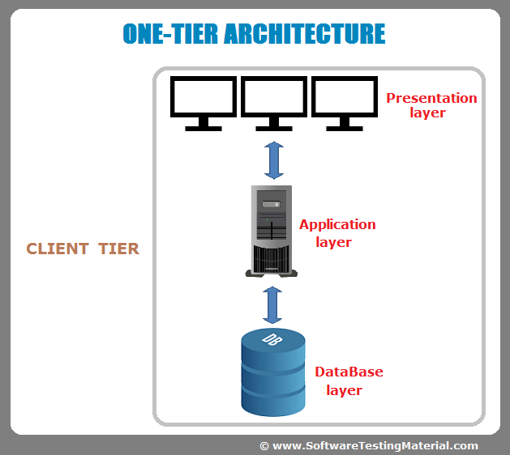.

One tier architecture has all the layers such as Presentation, Business, Data Access layers in a single software package. Applications which handles all the three tiers such as MP3 player, MS Office are come under one tier application. The data is stored in the local system or a shared drive.

Basically, a one-tier architecture keeps all of the elements of an application, including the interface, Middleware and back-end data, in one place. Developers see these types of systems as the simplest and most direct way.

**Two-Tier Architecture:**

Two Tier application AKA Client-Server application

The Two-tier architecture is divided into two parts:

1. Client Application (Client Tier)

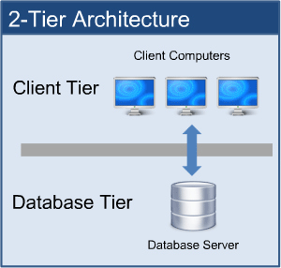2. Database (Data Tier)

The two-tier is based on Client Server architecture. The two-tier architecture is like client server application. The direct communication takes place between client and server. There is no intermediate between client and server.

Client system handles both Presentation and Application layers and Server system handles Database layer. It is also known as client server application. The communication takes place between the Client and the Server. Client system sends the request to the Server system and the Server system processes the request and sends back the data to the Client System.

**Three-Tier Architecture:**

Three Tier application AKA Web Based application

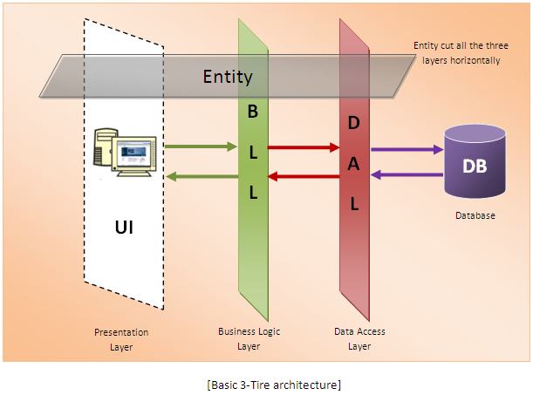A 3-tier architecture separates its tiers from each other based on the complexity of the users and how they use the data present in the database. It is the most widely used architecture to design a DBMS.This architecture has different usages with different applications. It can be used in web applications and distributed applications. The strength in particular is when using this architecture over distributed systems.

* **Database (Data) Tier** − At this tier, the database resides along with its query processing languages. We also have the relations that define the data and their constraints at this level.
* **Application (Middle) Tier** − At this tier reside the application server and the programs that access the database. For a user, this application tier presents an abstracted view of the database. End-users are unaware of any existence of the database beyond the application. At the other end, the database tier is not aware of any other user beyond the application tier. Hence, the application layer sits in the middle and acts as a mediator between the end-user and the database.
* **User (Presentation) Tier** − End-users operate on this tier and they know nothing about any existence of the database beyond this layer. At this layer, multiple views of the database can be provided by the application. All views are generated by applications that reside in the application tier.

# **N-Tier Architecture:**

N-tier architecture would involve dividing an application into three different tiers. These would be the

1. 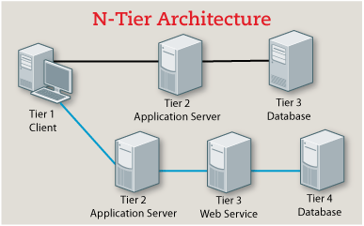logic tier,
2. the presentation tier, and
3. the data tier.

It is the physical separation of the different parts of the application as opposed to the usually conceptual or logical separation of the elements in the model-view-controller (MVC) framework. Another difference from the MVC framework is that n-tier layers are connected linearly, meaning all communication must go through the middle layer, which is the logic tier.